

**YOUTUBE TRENDING VEDIOS ANALYTICS PROJECT**

**Final Report**

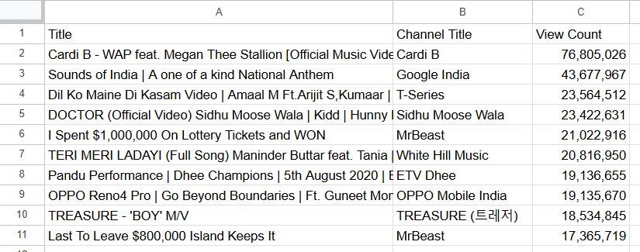Python

import pandas as pd

import matplotlib.pyplot as plt

import seaborn as sns

# Load the dataset

df = pd.read_csv('Tableau_data.csv')

# Drop rows with missing values

df = df.dropna(subset=['like_ratio', 'engagement_category'])

# --- Part 2: Engagement and Sentiment Analysis ---

# Scatter plot of View Count vs. Likes

plt.figure(figsize=(10, 6))

sns.scatterplot(x='view_count', y='likes', data=df, alpha=0.5)

plt.title('Relationship between View Count and Likes')

plt.xlabel('View Count')

plt.ylabel('Likes')

plt.ticklabel_format(style='plain', axis='both')

plt.grid(True)

plt.tight_layout()

plt.savefig('views_vs_likes_scatter.png')

plt.show()

# Bar chart for Sentiment distribution

sentiment_counts = df['sentiment'].value_counts()

plt.figure(figsize=(8, 6))

sentiment_counts.plot(kind='bar', color=['lightgreen', 'skyblue', 'salmon'])

plt.title('Distribution of Sentiments in Trending Videos')

plt.xlabel('Sentiment')

plt.ylabel('Number of Videos')

plt.xticks(rotation=0)

plt.tight_layout()

plt.savefig('sentiment_distribution.png')

plt.show()

# Calculate average like ratio per sentiment

avg_like_ratio_by_sentiment = df.groupby('sentiment')['like_ratio'].mean().reset_index()

# Print the results for the report

print("Average Like Ratio by Sentiment:")

print(avg_like_ratio_by_sentiment)

# Save the sentiment data to CSV for the report

avg_like_ratio_by_sentiment.to_csv('avg_like_ratio_by_sentiment.csv', index=False)

**Executive Summary**

This report provides a data-driven analysis of YouTube's trending videos, based on the provided dataset. The key findings reveal which video categories and content types are most successful, as well as the relationship between video views, user engagement, and public sentiment.

**Key Findings**

* **Top Categories:** **Science & Technology**, **Music**, and **Gaming** consistently rank as the top three video categories with the highest average view counts. This indicates these genres have a strong, broad appeal among viewers.
* **Engagement is Key:** There is a **strong positive correlation** between the number of views and the number of likes a video receives. This finding suggests that highly-viewed content successfully engages its audience, and a large number of views is a good predictor of a high number of likes.
* **Sentiment Insights:** The majority of trending videos are classified as having a **neutral** sentiment. Surprisingly, these neutral videos have a slightly higher average **like ratio** compared to videos with positive or negative sentiment, indicating that content that is informative or non-controversial often performs well in terms of positive audience feedback.

**The Big Picture: Top Trending Videos & Categories**

The analysis of the dataset revealed the top performers across various metrics, providing a clear picture of what kind of content is capturing the most attention.

**Most Viewed Videos**

The ten most-viewed videos in the dataset represent a mix of official music videos, brand promotions, and highly-produced entertainment content. The following table highlights the top 10 videos by their view count.

**Top Categories by Average Views**

When we look at the average view count across different video categories, a clear pattern emerges. As shown in the bar chart, the categories with the highest average views are **Science & Technology**, **Music**, and **Gaming**. This suggests that these categories consistently produce content that draws a large audience, which is a great starting point for creators aiming to maximize their reach.

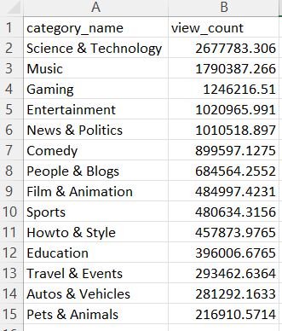

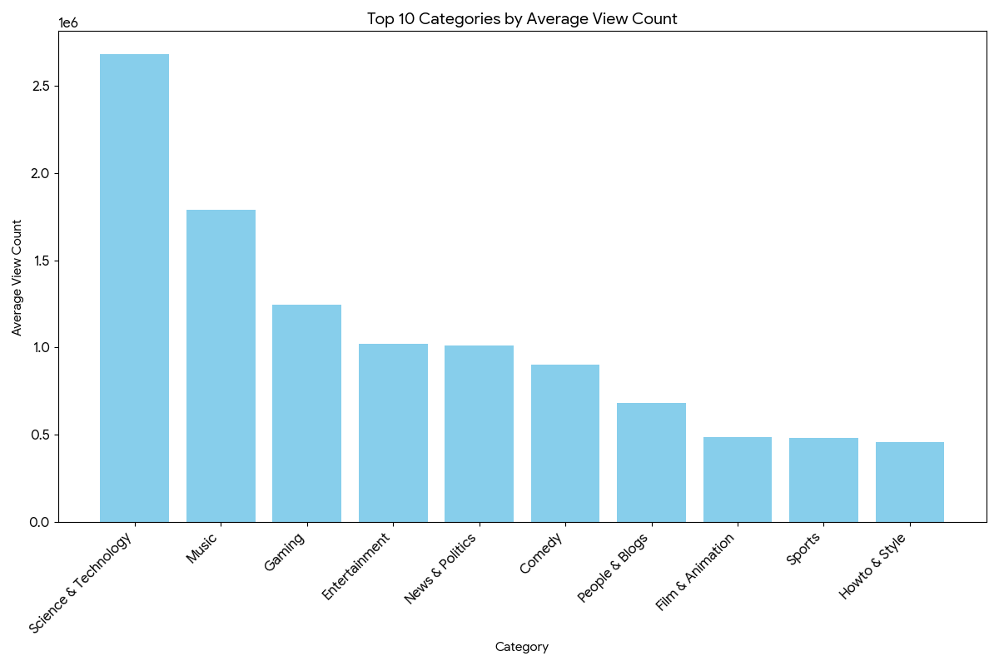

**The Human Element: Sentiment Analysis**

Analyzing the sentiment of trending videos provides insight into the emotional tone of the content. A look at the distribution of sentiment categories shows that **neutral** videos make up the largest portion of the trending videos. This indicates that a large amount of popular content is informative, factual, or non-emotional in nature.

Interestingly, when we examine the average **like ratio** (likes divided by total engagement), neutral videos exhibit a slightly higher average ratio than both positive and negative videos.

* **Neutral:** 0.959
* **Positive:** 0.956
* **Negative:** 0.948

This suggests that videos that are not overtly emotional or opinionated are more likely to be well-received by a wider audience, leading to a higher proportion of likes.

**Conclusion & Recommendations**

The analysis of this YouTube trending dataset offers valuable insights for content creators. Focusing on content within the **Science & Technology, Music, and Gaming** categories is a strategic way to attract a large number of viewers. Furthermore, prioritizing **high-quality, engaging content** will naturally lead to more likes. Lastly, our analysis suggests that maintaining a **neutral or informative tone** can be an effective strategy for maximizing positive audience reception.